Nutrition Test Study Guide
Vocabulary:
- My Plate – a diagram which helps me understand how much of each food group I should have during each meal of the day

- Fiber – a substance found in plants which helps food and waste move through your digestive tract

- Water – the nutrient which is necessary forlife

- Vitamins – nutrients which help your body perform specific functions

- Water soluble vitamins – vitamins which are not stored in your body

- Fat soluble vitamins – vitamins which are stored in your body, too much can be harmful

- Minerals – nutrients which help your body grow and work

- Serving – measured amount of food or drink you would probably eat during one meal

- Healthy decision making process – steps used to help you choose a healthy snack

- Balanced diet – eating a variety of foods from each of the food groups daily

Concepts to Learn

- There are 6 essential nutrients; carbohydrates, fats, proteins, vitamins, minerals, water

- Vitamins and minerals help your body do a specific function.

- Fats, proteins and carbohydrates produce energy for your body.

- There are five food groups on the My Plate diagram; proteins, grains, dairy, vegetables and fruits.
  - For a food to be considered a dairy product on the plate it must contain calcium.

- At least half of your plate should contain vegetables and fruits, with more vegetables.

- There are two types of grains; refined grains and whole grains.
  - Whole grains are the healthiest for you
  - refined grains break down into sugar in your body.
  - More then half of your grains should be whole each day

- Vitamins are separated into two groups
  - fat soluble vitamins are stored in your body
  - water soluble vitamins are not stored in your body

- Calcium is an important mineral. It is needed to build strong bones and teeth. It can be found in dairy products or leafy green vegetables.

- Each vitamin has one or more specific job in the body.
  - Vitamin A helps you see at night.
  - Vitamin C creates strong bones and teeth.

- Vitmain D is the only vitamin your body can produce on its own. You can get some from the sun.

- Vitamin B helps create energy for the body.

- There are four steps to the healthy decision making process.
  - Find out about each choice you can make.
  - Imagine the result of each choice.
  - Make what you think is the best choice.
  - Think about what happened as a result of your choice.

- Food labels list ingredients and nutrition information. Food labels allow you to compare two foods and understand serving size.

Study every night to prepare for the test. If you have any questions, please come talk to me. Be sure to check out the website page for a copy of the studyguide, some review videos from class and other exciting info or games I have found to help you!
Return the bottom of this study guide which states that you studied every single night to prepare for the test for a special bonus!

_____________________________________________________

Name ____________________________

Parents Signature __________________________________

Student Signature ______________________________________

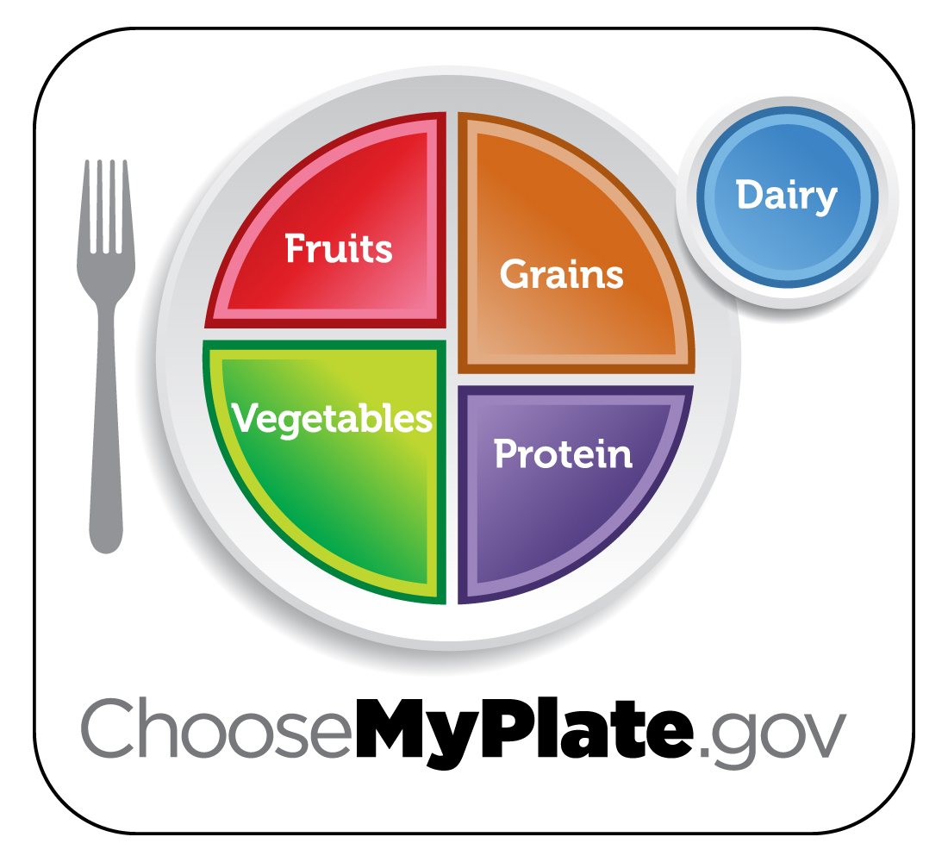
Study this diagram

