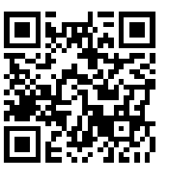
Science Fair Due Dates:

Week of January 12th – Collect your materials for your project. Hand in a list of the materials you will be using to me by January 16th.

Week of January 19th - Begin to set up your experiment and start recording your results. Write your daily observations down in a notebook or on observation sheets. Hand in two observation forms on January 26th.

Week of February 23rd- Science Fair check up – A note will follow in regards to this

March 2nd – Complete the experiment by this date. Analyze your results this week and begin to write your conclusion.

Week of March 9th – Set up the Science fair display board. Make charts, graphs, visuals to display on the board. (Note with information will follow)

March 20th – Project due in class

Notices in regards to each of these items will follow through out the next couple of months. Be sure to check our class website for important information to help you complete the project as well as your child’s folder for notices. Email me with any questions as always.

http://mrsciolino4.weebly.com/science-fair.html

